**E-Book Online System**



**E-Project**

**Group Members**

|  |  |
| --- | --- |
| **Student Name** | **Enrollment No** |
| **Mr.Furqan-ur-Rehman** | Student1311432 |
| **Mr. Hassan Mujtaba** | Student1311640 |
| **Mr. Farzam Ahmed** | Student1312165 |
| **Mr. Muhammad Wahaj** | Student1312214 |

**Faculty: Miss Muniba Javed Khan**

**Batch Co-Coordinator: Miss Ariba Ali**

**Batch: 2104B1**

**Curriculum: OV-ACCP-PRIME (6740)**

**User Guide**

**Home Page**

* User view home page.
* At very first user will see the Competition Page banner on the home page

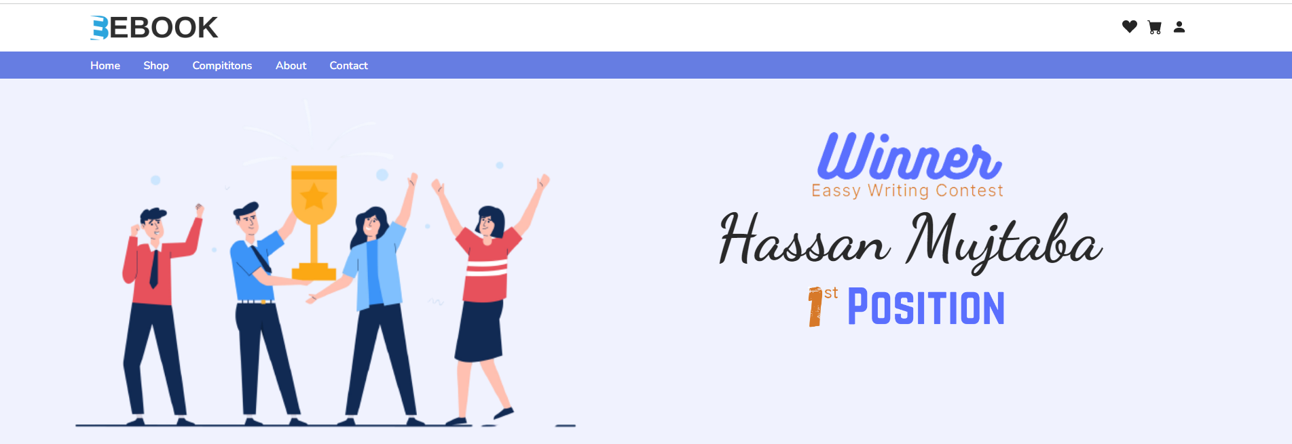

* User will at the second trending books section.

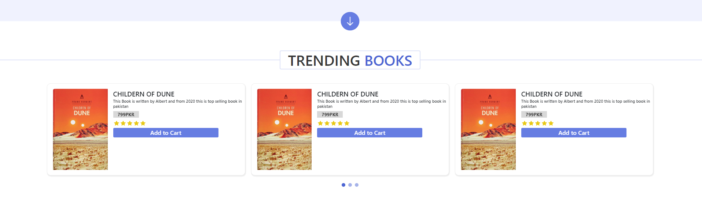

* User can see the discount section on the home page



* User can also see the newly launched book section on the home page.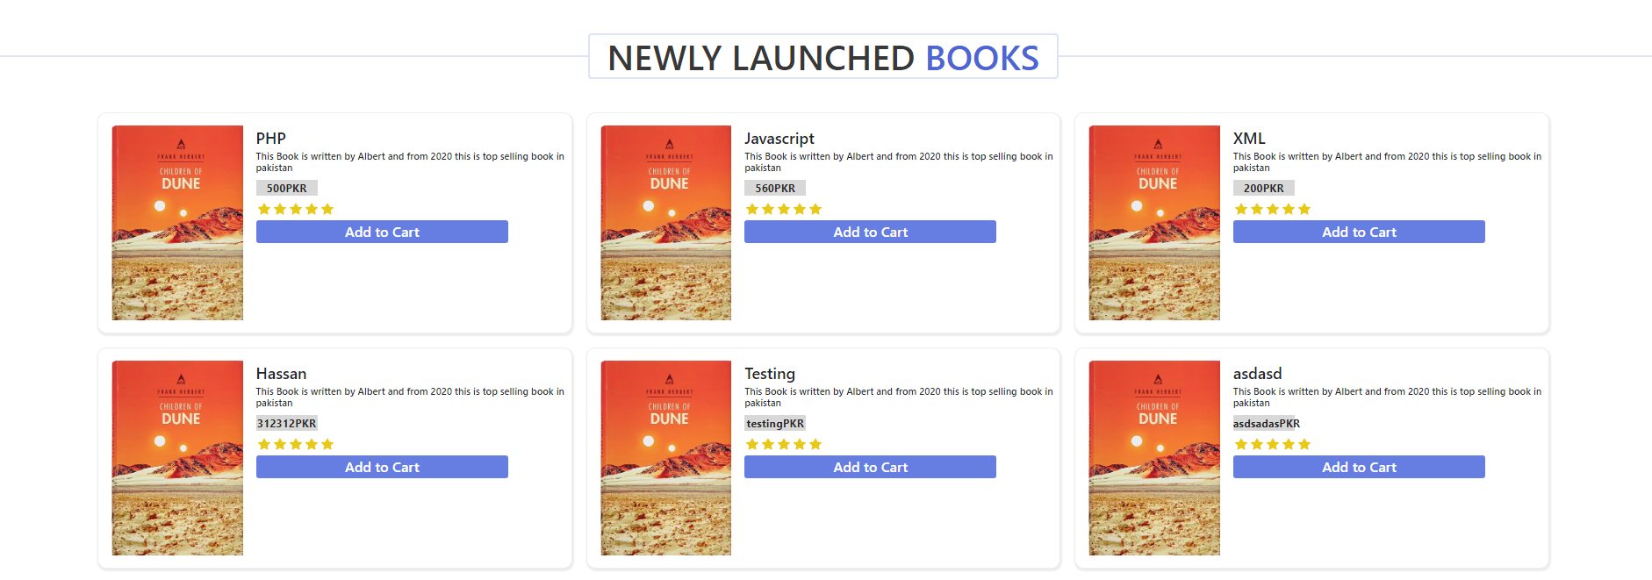
* Users can see the home reviews section for a book author.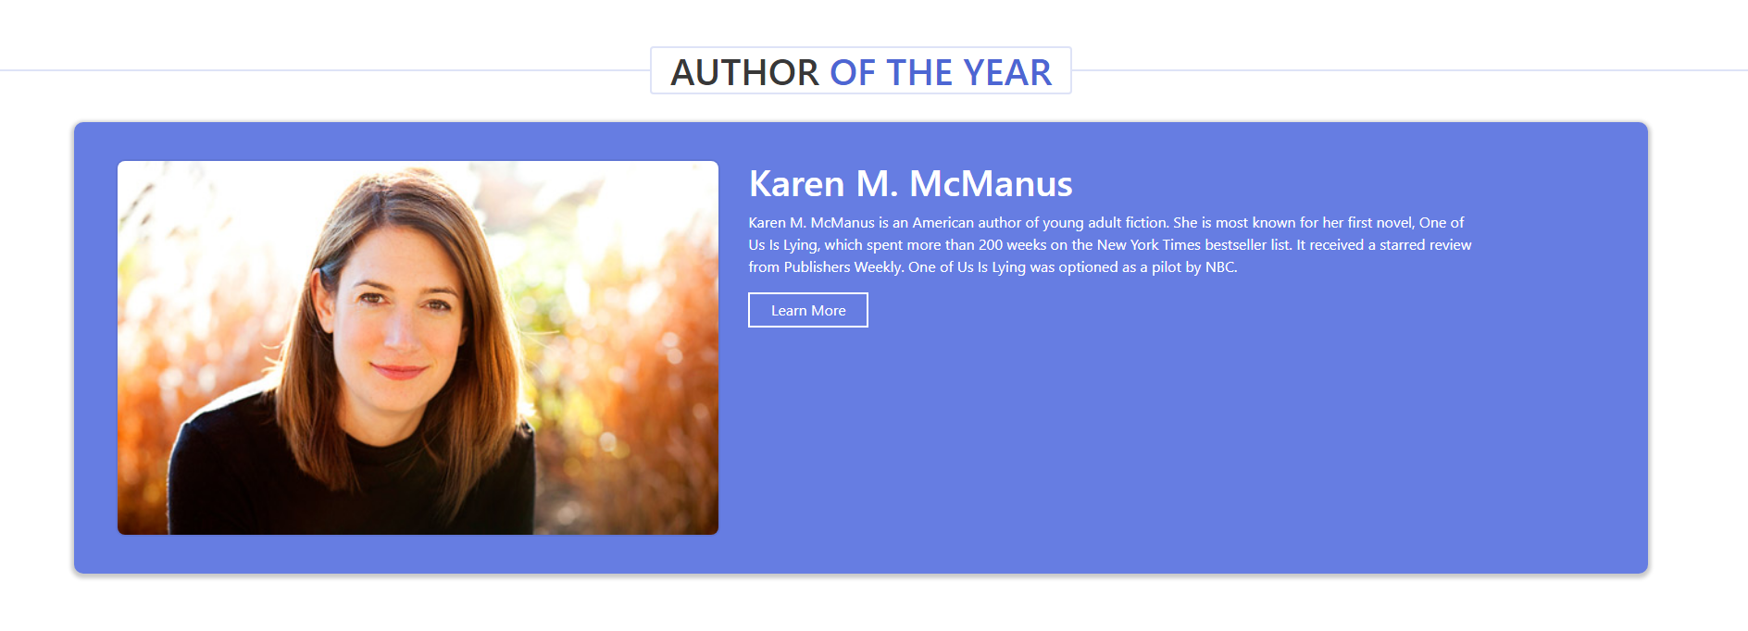
* User can see here the books category. 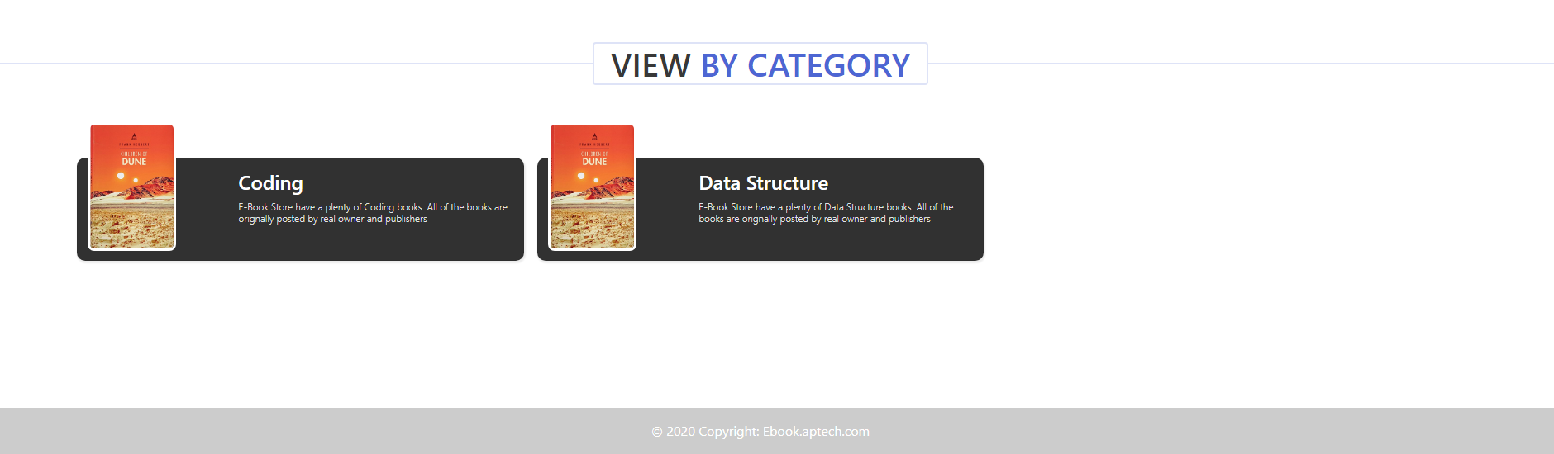

**Books Page**

* User can see the books section on the navigation bar where user can easily search books for reading and purchase.

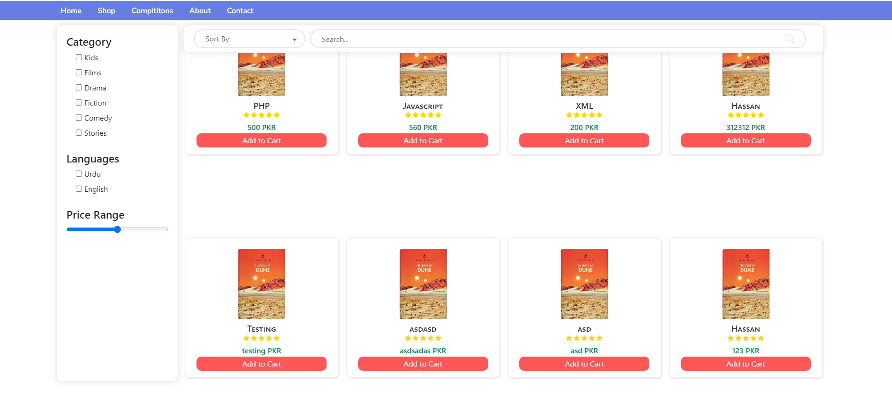

**About Us Page**

* Users can know our journey by visiting this page.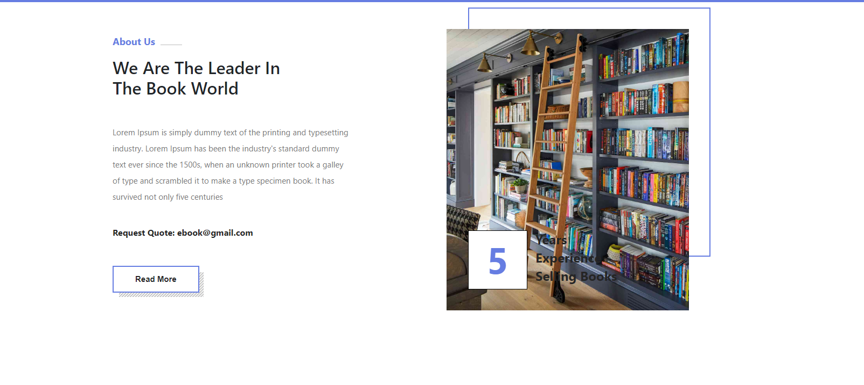

**Contact Us Page**

* This facility is for users to contact us through this page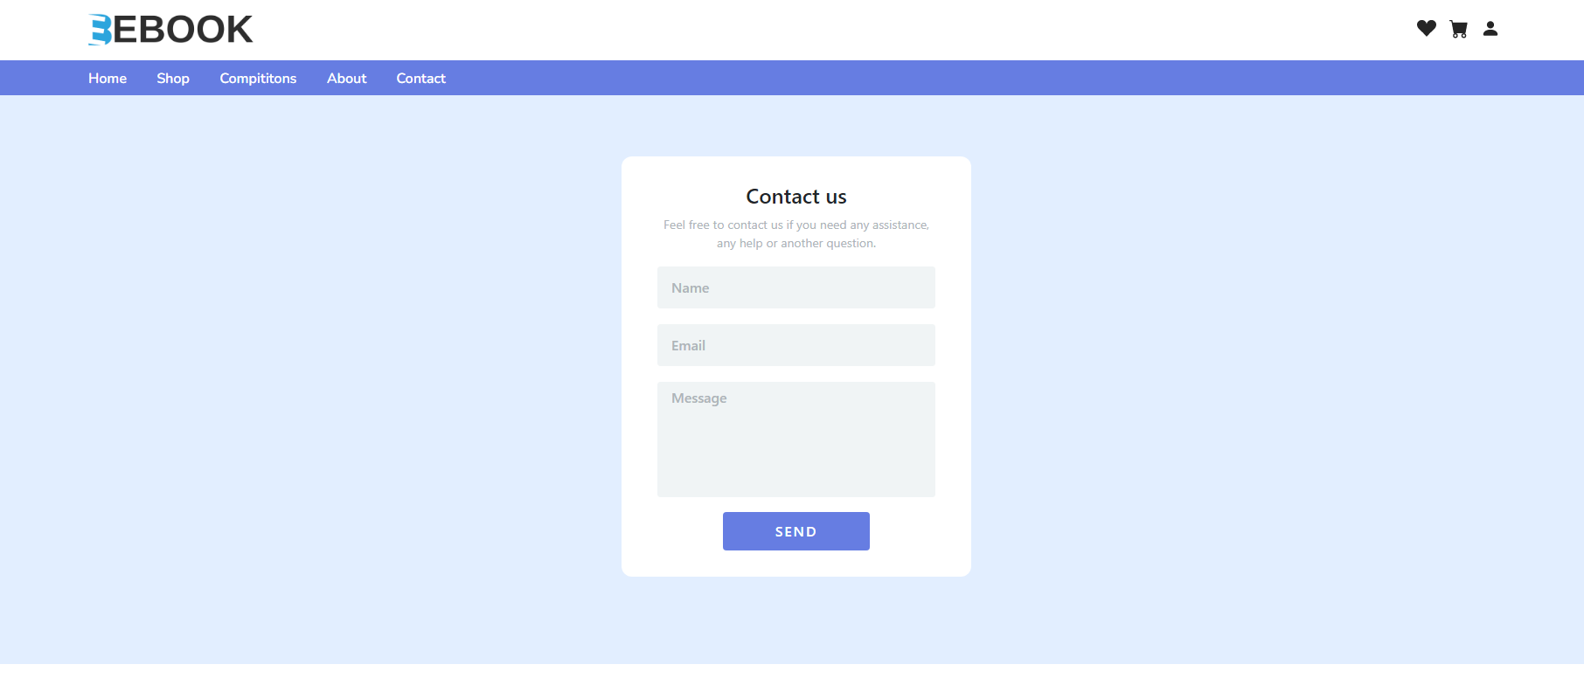

**Registration Page**

* Users must be registered to order the books, participate in the competition, and read the books. 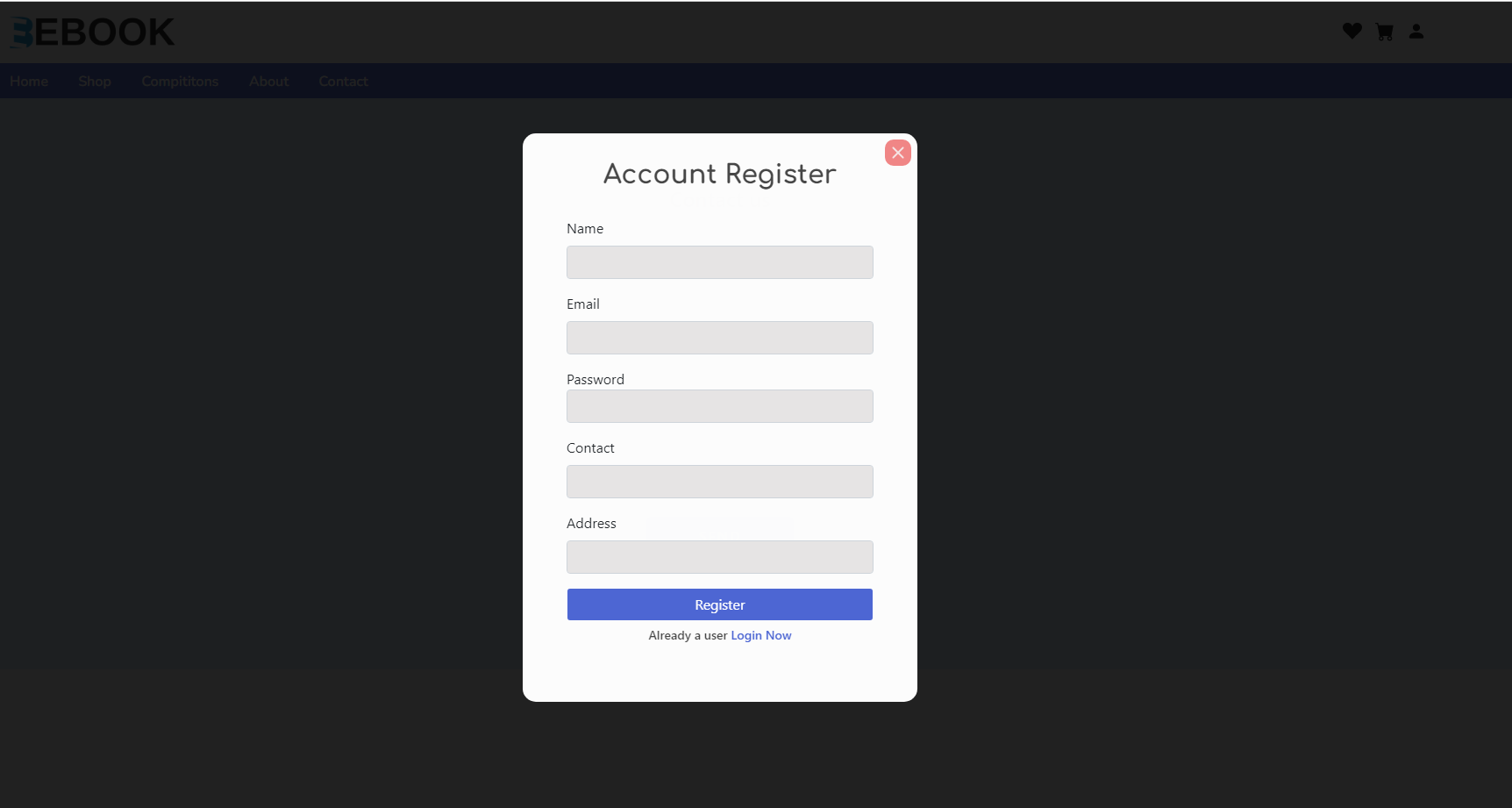

**Sign In Page**

* After completing the registration users can log in easily.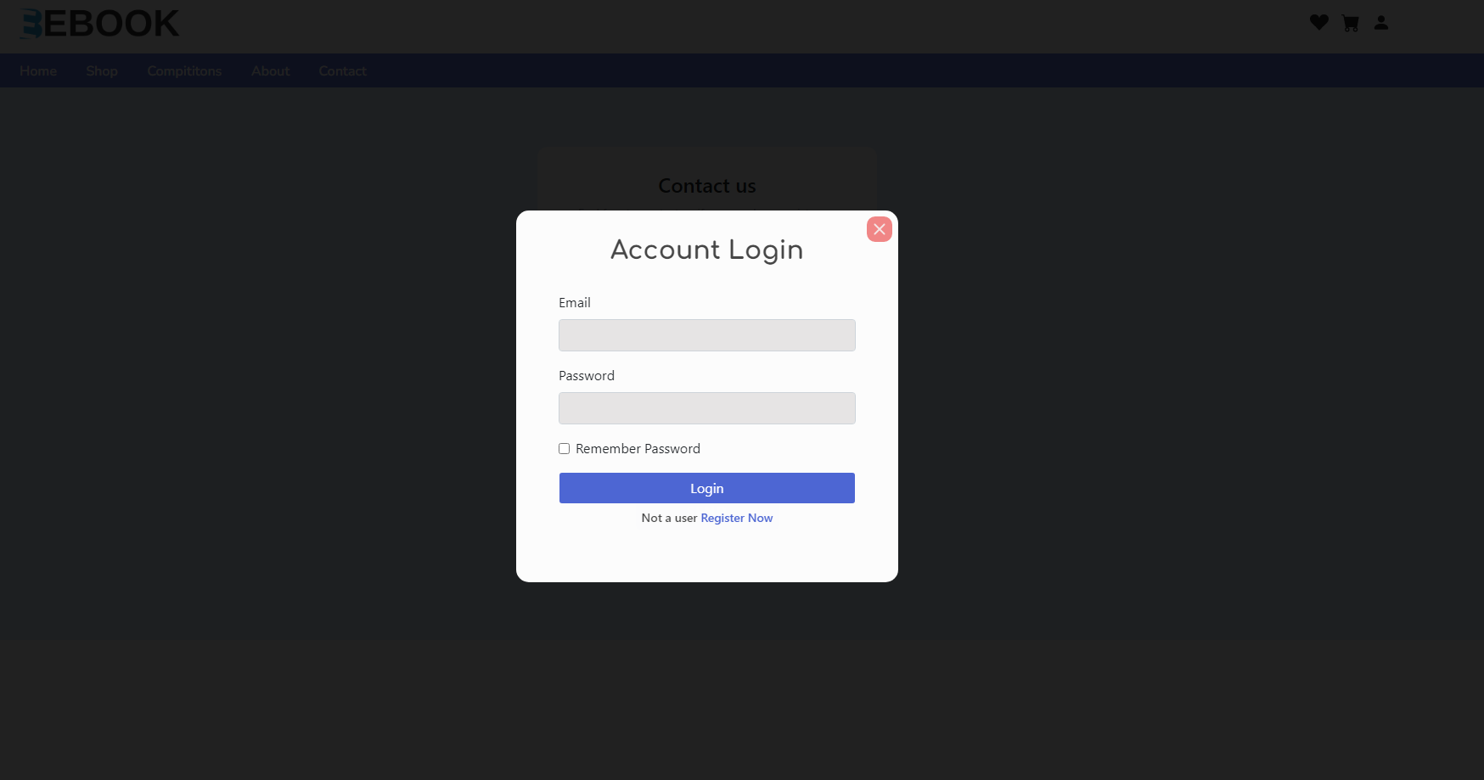

After completing the sign in process users can perform the tasks given below

**Add to Card Page**

* Users can add books to the cart to purchase books.

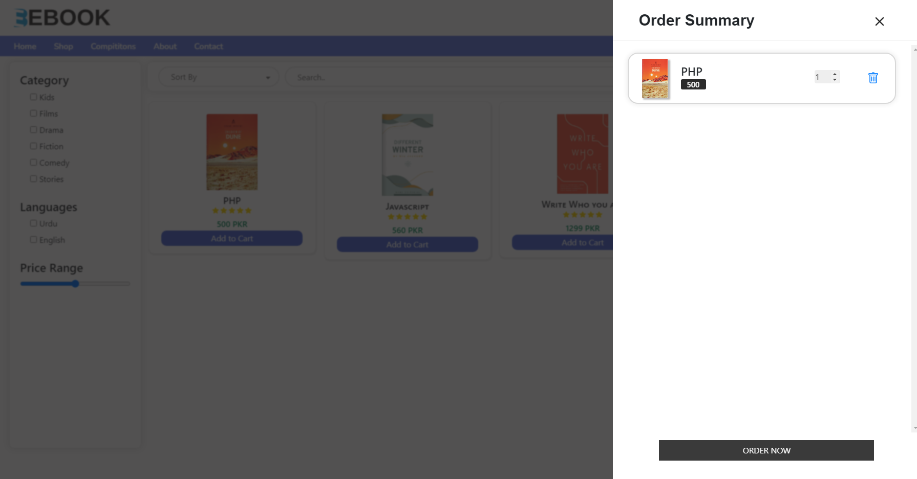

**Order Page**

* Users can order their required books.

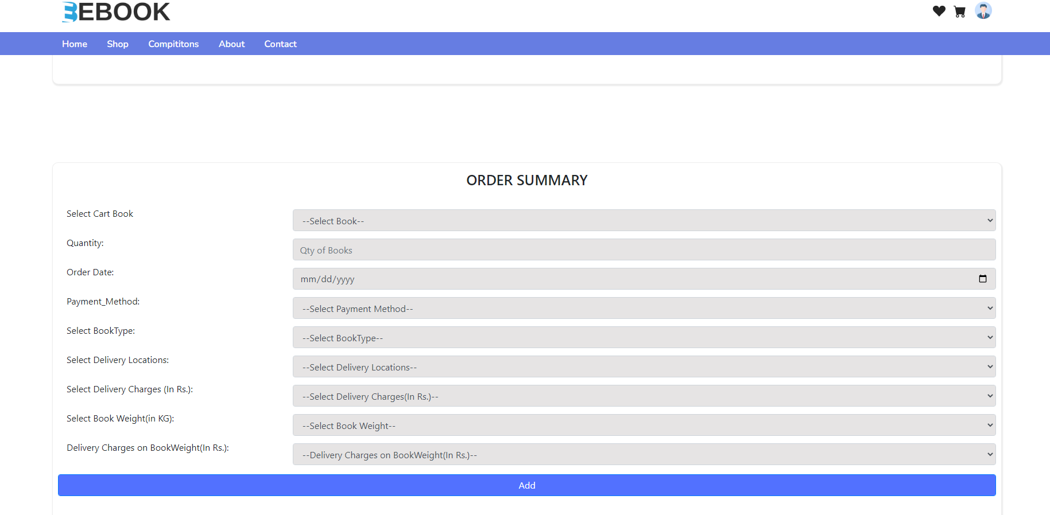

**Order Summary**

* After the order confirm user can see his order history.

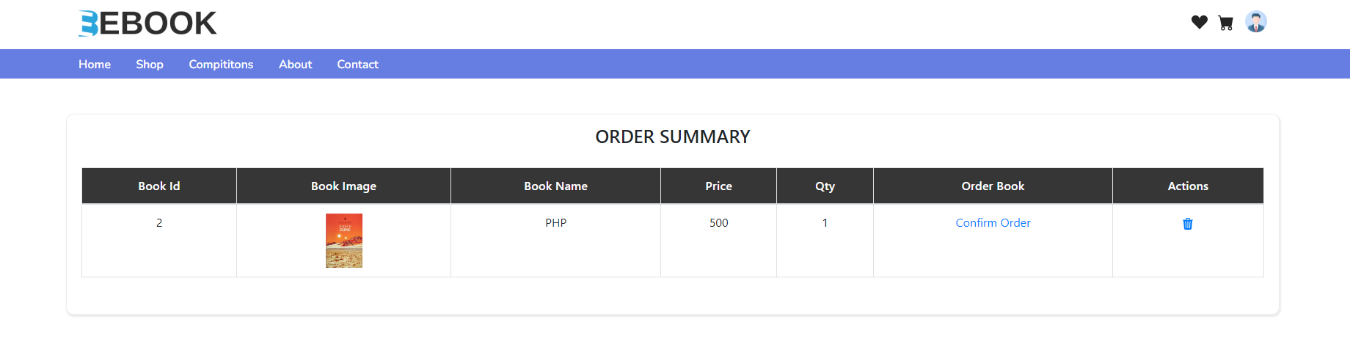

**Competition Page**

Users can participate in the competition through our website and win prizes.